

EastWest University

**Department of CSE**

**CSE 405**

**Computer Networking**

**SECTION: 02**

**Title: Design a full-Fledged network for an organization with multiple subnets.**

***Project Report***

**Submitted To:**

**Dr. Anisur Rahman**

**Asst.Professor ,**

**Department of CSE .**

**Submitted By:**

**Md. Sakibul Islam**

* **2016-2-60-060**

**Project Statement:**

The purpose of my project is to create a university based network. The project based on creating complete model of the complex network by discovering the interconnectivity of the system and subnetworks, which will reflect the Apex University curriculum. This project is about configure a DHCP which is automatically assign IPv4 addresses to any host. Also DNS server ,HTTP protocol used in this project. Here I use cisco packet tracer and implemented window.

**Overview of Three main services:**

In my project I have used Cisco Packet Tracer for the implementation. There are three main services, One is Dynamic Host Configuration Protocol (DHCP) ,Second one is Hyper Transfer Protocol (HTTP), Third one is Domain Name System (DNS).  
  
DHCP is a network protocol that enables a server to automatically assign an IP to a computer from defined range of numbers configured for a given network. DHCP allows to move a computer, such as a laptop, among various locations without reconfiguring the TCP/IP setting. For example, if a faculty member had a laptop which he wanted to take from his office to a networked classroom to present in class, DHCP will allow the laptop to hook to the network in both locations without reconfiguring the computer.

In this project’s network model, there is a single server (DHCP), which is connected to a switch. That switch is connected to other five routers connected to switch that refer to Academic, Classrooms, ICS labs, faculty, employee, digital lab, and library. Each server is a sub-network. In the DHCP server there are few numbers of ports where I use only two port to connect a switch that creates sub-network. In future which can be expanded creating subnets from them? These are the wired network connections. Alongside of those, we I used 1 wireless switch so that one can connect there tablet or mobile phone and use internet service.

HTTP is designed to permit intermediate network elements to improve or enable communications between clients and servers. High-traffic websites often benefit from [web cache](https://en.wikipedia.org/wiki/Web_cache) servers that deliver content on behalf of [upstream servers](https://en.wikipedia.org/wiki/Upstream_server) to improve response time. Web browsers cache previously accessed web resources and reuse them when possible to reduce network traffic. HTTP [proxy servers](https://en.wikipedia.org/wiki/Proxy_server) at [private network](https://en.wikipedia.org/wiki/Private_network) boundaries can facilitate communication for clients without a globally routable address, by relaying messages with external servers.

DNS server is the Internet’s equivalent. It maintain a directory of domain names and translate them to Internet Protocol addresses.

Using this configuration I tried to create that complete model of complex network that reflects the Apex University curriculum.

**Tools or components :**

1.One DHCP Server

2. One DNS Server

3.One HTTP

4. Eleven Switches

5. Five routers

6. Twenty four hosts

7.One smart phone

8. Connector

**Procedure:**

First I take hosts from where admission ,advising ,lab and different types of activities are done. To interface the host I take switch. Then used router for making network. After that I take DHCP server, DNS server and HTTP server. The DNS server is for HTTP server. So the web server can be workable . Everything ought to be associated with wire at that point. Then we will assign gateway IP in the router. The router will recognize server and switch with those gateway IP.

We assign the IP’s of switch or server which will be recognizable to router. Those will be their default gateway IP. We will also assign the server IP.

Now, we make recognizable the switch side network to router.

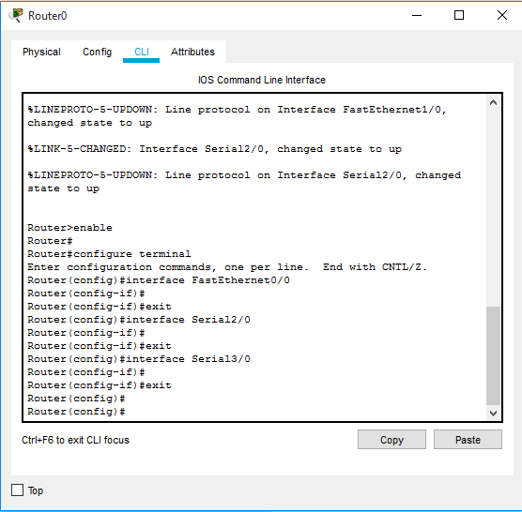

Router0

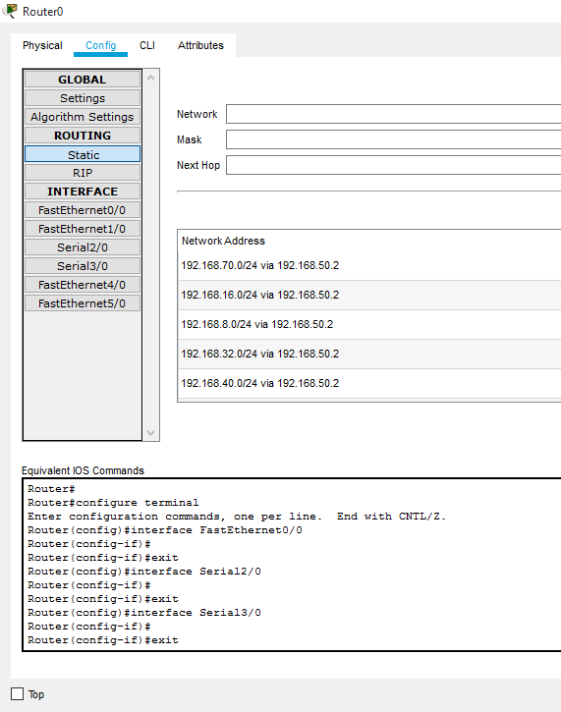

Here is the static mode.

Similarly ,

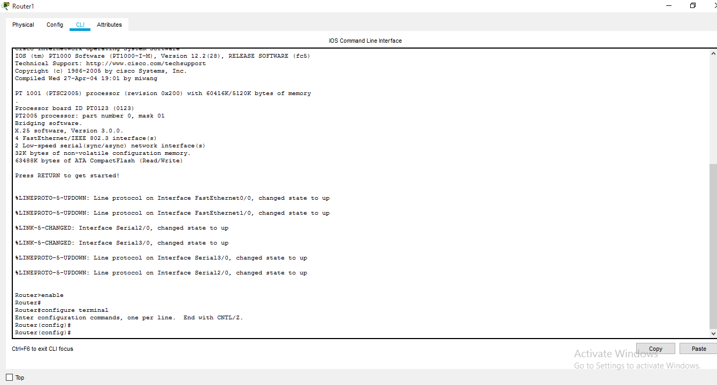

. 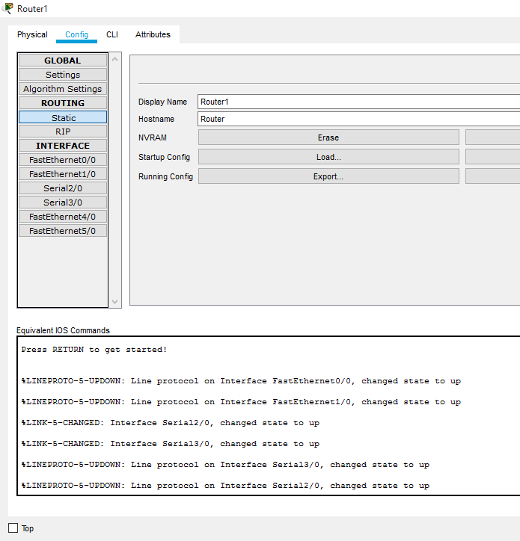

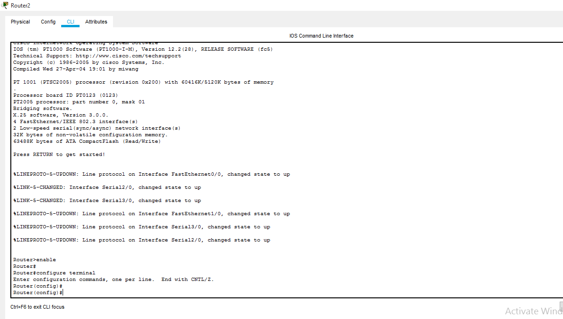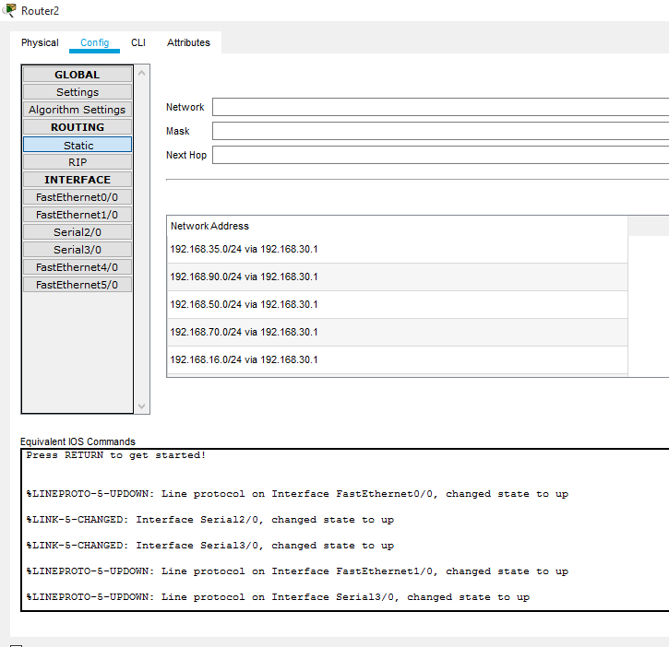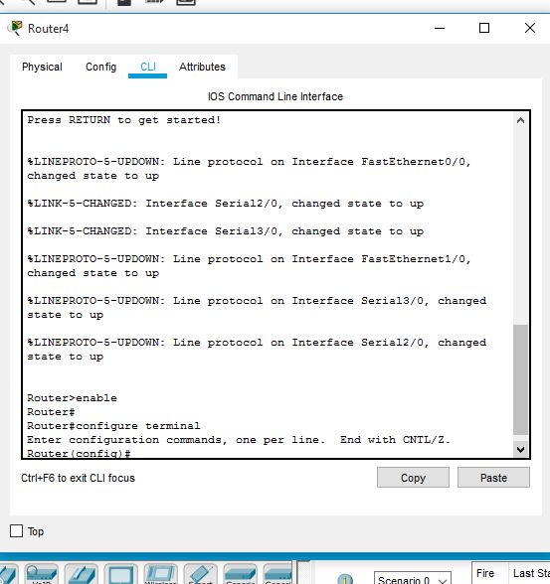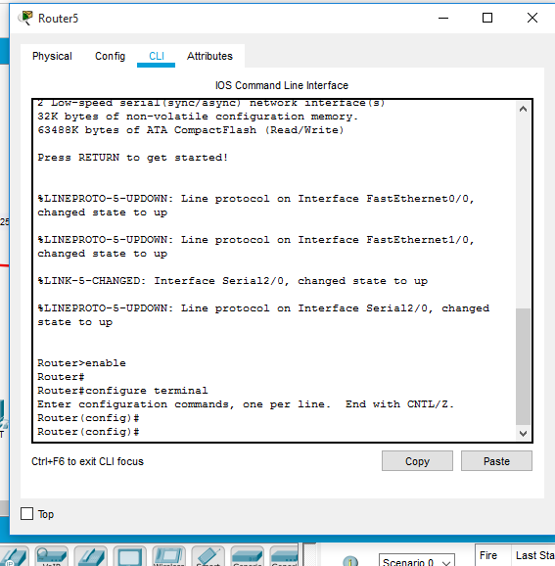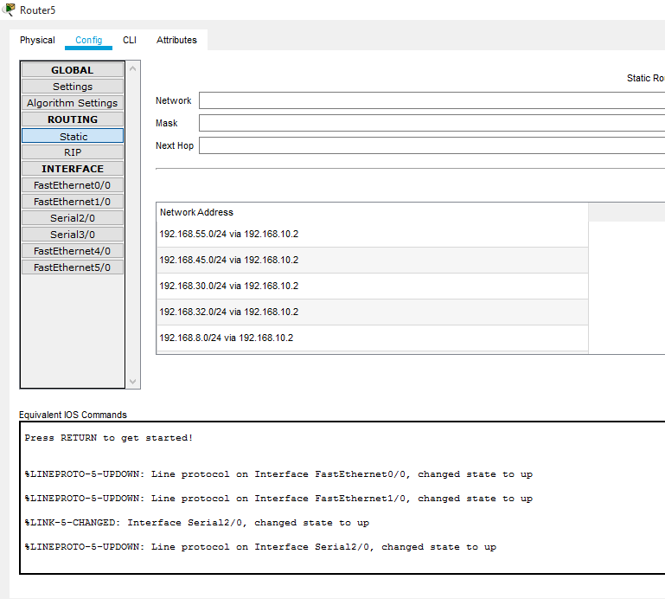

My Entire project in cisco packet is ,

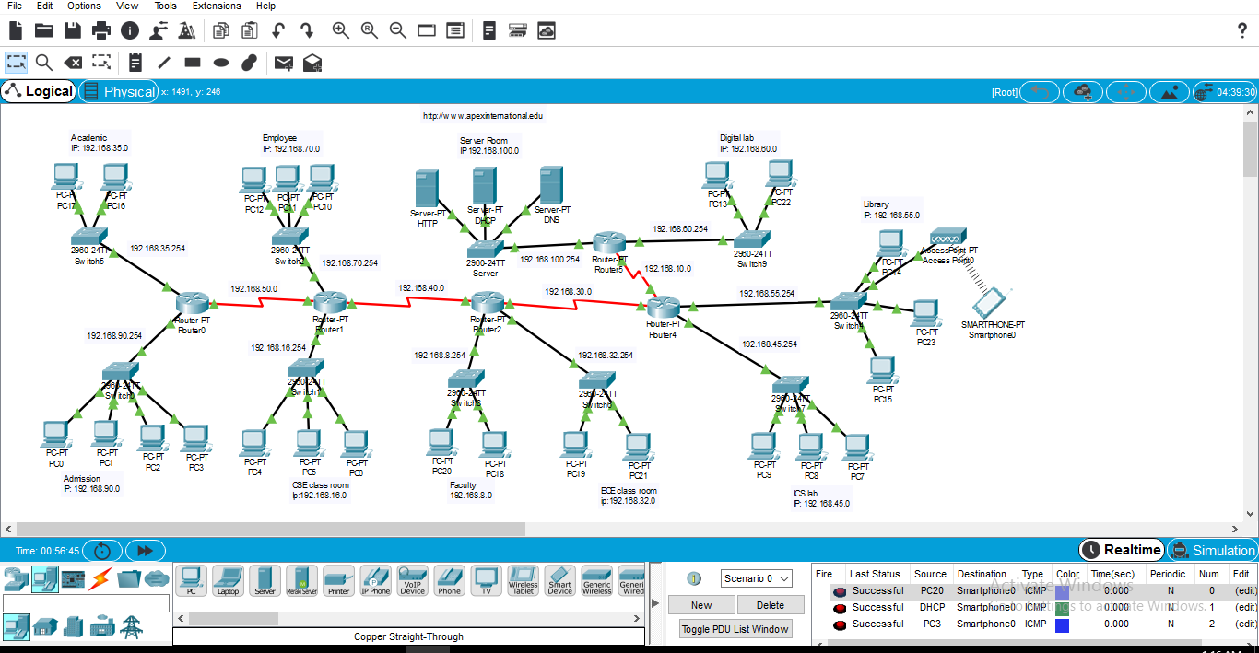

The over view of web page is ,

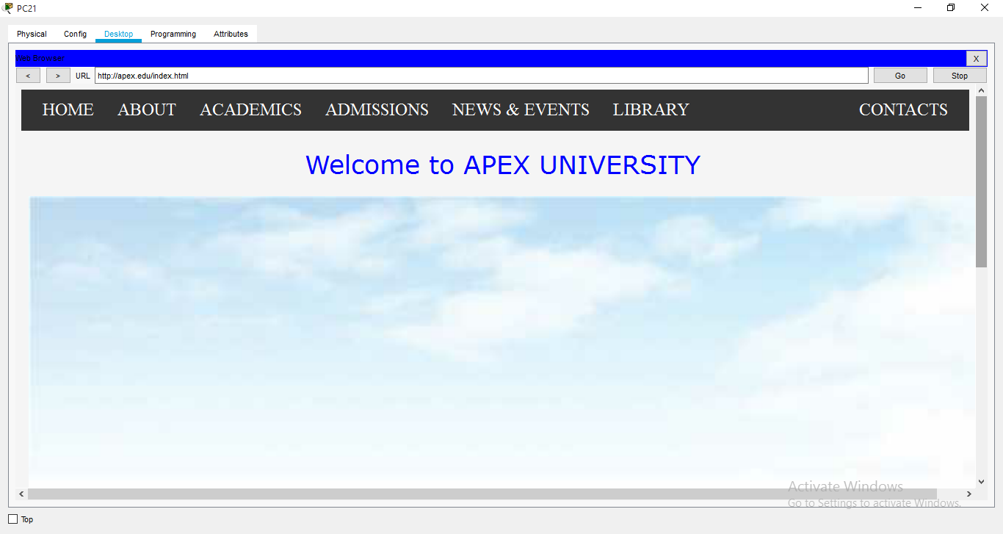

**Conclusion:**

In this project, I have implemented DHCP ,DNS and HTTP in Cisco Packet Tracer, where the configuration of DHCP is automatically assign IPv4 address to any other host from the assigned IPv4 address block of the design. Also used web-server generates webpage which reflects the University profile.